L.J. SCHOOL OF COMPUTER APPLICATIONS

Small Shopping Site

Group No: - 01

Under the Guidance of:
Anurag Jobanputra
Developed By:
1.  2.  3. | Jetani Abhishek Kanubhai  Janwani Mohit Deepakbhai  Shah Mudit Apurvabhai | 21008501210022  21008501210021  21018501210057

L.J. SCHOOL OF COMPUTER APPLICATIONS

CERTIFICATE
Enrolment No: 21008501210022 Seat No: _________
This is to certify that Mr. Jetani Abhishek Kanubhai of Integrated Master of Computer Applications, Semester 9 has satisfactorily completed his project title Small Shopping Site under the supervision of Anurag Jobanputra.

Internal Guide Name Head of Department
_________________ Dr. Monica Gahalawat
Signature
Date of Submission: _______________
Director
Prof. Alok Mank

L.J. SCHOOL OF COMPUTER APPLICATIONS

CERTIFICATE
Enrolment No: 21008501210021 Seat No: _________
This is to certify that Mr. Janwani Mohit Deepakbhai of Integrated Master of Computer Applications, Semester 9 has satisfactorily completed his project titled Small Shopping Site under the supervision of Anurag Jobanputra.

Internal Guide Name Head of Department
_________________ Dr. Monica Gahalawat
Signature
Date of Submission: _______________
Director
Prof. Alok Mank


CERTIFICATE
Enrolment No: 21008501210021 Seat No: _________
This is to certify that Mr. Mudit Apurvabhai Shah of Integrated Master of Computer Applications, Semester 8 has satisfactorily completed his project titled Small Shopping Site under the supervision of Anurag Jobanputra.

Internal Guide Name Head of Department
_________________ Dr. Monica Gahalawat
Signature
Date of Submission: _______________
Director
Prof. Alok Manke

Table of Contents

1. Introduction 7
1.1 Existing System 8
1.2 Need for the New System 8
1.3 Objective of the New System 9
1.4 Problem Definition 10
1.5 Core Components 10
1.6 Project Profile 12
1.7 Assumptions and Constraints 12
1.8 Advantages and Limitations of the Proposed System 14
1.9 Proposed Time Line Chart 16
2. Requirement Determination & Analysis 17
2.1 Requirement Determination 17
2.2 Targeted Users 18
3 System Design 19
3.1 Use Case Diagram 19
3.2 Class Diagram 21
3.3 Interaction Diagram 21
3.4 Activity Diagram 22
3.5 Data Dictionary 23
3.6 User Interface 26
4. Development 37
4.1 Coding Standards 37
5. Agile Documentation 38
5.1 Agile Project Charter 38
5.2 Agile Road Map 38
5.3 Agile Project Plan 38
5.4 Agile User Story ( Minimum 3 Tasks) 38
5.5 Agile Release Plan 38
5.6 Agile Sprint Backlog 38
5.7 Agile Test Plan 38
5.8 Earned-value and burn charts 38
6. Proposed Enhancements 39
7. Conclusion 40
8. Bibliography 41

1. INTRODUCTION
This project represents the development of a small but fully functional online shopping platform built using the Laravel framework. The system is designed to simulate the core functions of a modern e-commerce platform similar to popular sites like Amazon or Flipkart. Through this platform, users can browse a wide range of products, view product details, add items to their shopping cart or wishlist, and proceed through a secure checkout process to complete purchases.

In addition to user-focused features, the system also includes comprehensive administrative functionality. Administrators can manage products, categories, and user accounts while monitoring real-time activity on the site. The admin dashboard helps in tracking sales trends, top-selling items, user growth, product performance, and overall system usage.

E-commerce has become an essential component of modern retail, and small businesses increasingly require digital solutions to reach wider audiences. However, many small-scale systems lack automation, centralized control, and essential features needed for operational efficiency and customer satisfaction. This project aims to fill that gap by offering a streamlined, fully integrated, and user-friendly online shopping system.

1.1 EXISTING SYSTEM
Currently, many small-scale e-commerce websites face several limitations that impact both user experience and business efficiency. Common issues in existing systems include:

- Manual Processes for Product Management: Adding, updating, and managing products and categories often involves manual processes, leading to inefficiencies, errors, and delays in product availability.
- Limited User Access and Engagement: Without advanced user features such as cart, wishlist, and personalized recommendations, customers are less likely to engage deeply or make multiple purchases.
- Decentralized Product and Category Management: Many systems lack a centralized way to organize and control products by category, making it challenging for users to browse and filter products based on their preferences.

1.2 NEED FOR THE NEW SYSTEM
A new system is essential to overcome the limitations of the existing e-commerce approach. The "Small Shopping Site" aims to:

- Automate and Centralize Product and Category Management: By creating a centralized platform, all products and categories are organized systematically, enabling seamless updates and real-time availability of inventory.
- Enhance Transparency and User Experience: Users gain clear access to product details, prices, and availability. Features like a shopping cart, wishlist, and secure checkout streamline the shopping experience, leading to better user satisfaction and engagement.
- Empower Admins with Greater Control: Site administrators gain advanced control over product visibility and can track the most popular products, total users, and top-selling items. This provides valuable insights for inventory management and strategic decision-making.
- Improve Market Accessibility and Engagement: With a user-friendly interface, the platform makes it easier for users to find products by category, add them to their cart or wishlist, and complete purchases. This leads to higher engagement, increased sales, and a stronger customer base.

1.3 OBJECTIVE OF THE NEW SYSTEM
The main objectives of the "Small Shopping Site" system are to:
- Simplify Product Browsing and Purchasing: Enable users to easily explore categories, view product details, add items to a cart, and complete purchases within an intuitive platform.
- Centralize Product and Inventory Management: Provide admins with a centralized, real-time system to track products, inventory, and categories.
- Offer Personalization for Users: Allow users to save products to a wishlist and manage their cart for a more personalized shopping experience.
- Provide Advanced Insights for Admins: Offer analytics on top-selling products, user activity, and product counts, giving admins valuable insights for business growth.

1.4 PROBLEM DEFINITION
Current small-scale e-commerce systems face several limitations that the "Small Shopping Site" system seeks to address:
- Limited Inventory and Product Management Tools: Without a streamlined system, admins struggle to manage products and categories, leading to inefficient inventory handling and potential product unavailability.
- Lack of User Engagement Features: Conventional systems lack features like a wishlist, personalized cart, and streamlined checkout, making it harder for users to engage and complete purchases.
- Low Administrative Control and Visibility: Admins often lack insights into top-selling products and user activity, limiting their ability to make data-driven decisions.
- Inconsistent Shopping Experience: Without a centralized and user-friendly platform, users may encounter difficulties navigating categories, finding desired products, and making purchases.
The "Small Shopping Site" system aims to address these challenges by implementing a structured, user-friendly e-commerce platform.

1.5 CORE COMPONENTS
The core components of the "Small Shopping Site" system include:
- Product and Category Management Module
  - A centralized system for admins to add, update, delete, and organize products by category, enabling easy tracking and inventory management.
- User Account and Authentication Module
  - A secure system allowing users to register, sign in, and manage their accounts, supporting both regular users and admins with different levels of access.
- Shopping Cart and Wishlist Module
  - Features for users to add products to a shopping cart and wishlist, providing a personalized shopping experience that encourages engagement and repeat visits.
- Order Processing and Checkout Module
  - A streamlined order processing system where users can review cart items, update quantities, and proceed through a secure checkout process to place orders.
- Admin Dashboard and Analytics Module
  - An interactive dashboard for admins to monitor total users, product count, and sales insights, including a list of the top 5 best-selling products.
- User and Product Status Management Module
  - Admin controls for activating/deactivating users and products, helping to manage inventory and access based on business needs.
- Transaction History and Reporting
  - A system to record and display transaction histories for users, providing transparency and insight into their purchase history.

1.6 ASSUMPTIONS AND CONSTRAINTS
Assumptions:
- Product and Category Data: All products and categories uploaded by admins are accurate, complete, and organized for user clarity.
- User Engagement: Users will interact with features like the wishlist, cart, and checkout as intended, enhancing their shopping experience.
- Admin Access: Admins have the necessary permissions and resources to manage the dashboard, update products, and track sales effectively.
Constraints:
- Technical Limitations: Platform performance and scalability must be optimized to handle high volumes of users, especially during peak shopping times.
- User Access Requirements: Users require stable internet connectivity and compatible devices to access features like the cart, wishlist, and checkout.
- Compliance with E-commerce Regulations: The system must adhere to local and international e-commerce and data privacy regulations, such as GDPR, ensuring secure transactions and user data handling.

1.7 ADVANTAGES AND LIMITATIONS OF THE PROPOSED SYSTEM
Advantages:
- Enhanced Efficiency: A centralized platform automates product, category, and order management, reducing manual work and streamlining inventory handling.
- Improved User Experience: Features like the wishlist, cart, and secure checkout enhance user engagement, making it easy for customers to browse, save, and buy products.
- Admin Insights and Control: The dashboard provides admins with valuable insights into user activity, product popularity, and sales trends, helping with strategic planning.
- Real-Time Inventory Management: Automated stock updates help prevent overselling and ensure that product availability is always current, reducing customer frustration.
Limitations:
- Reliance on Accurate Data Entry: Any inaccuracies in product details or inventory data entered by admins may lead to user dissatisfaction and potential miscommunication.
- User Dependency on Internet Connectivity: Users require stable internet access to complete purchases and interact with features; poor connectivity may lead to cart abandonment.
- Regulatory Constraints: Compliance with data privacy and e-commerce regulations might limit certain features or require additional steps for data protection, impacting user experience.

1.8 Proposed timeline chart

Problem Definition | Month 1 |  |  |  | Month 2 |  |  |  | Month 3
 | Week1 | Week2 | Week3 | Week4 | Week1 | Week2 | Week3 | Week4 | Week1 | Week2 | Week3 | Week4
Objective of the New System
Core Components
Project Profile
Advantages of the Proposed System
Assumptions and Constraints
Requirement Determination
Targeted Users
Timeline Chart
Data Dictionary
Coding Standard
Screenshots
Agile Project Charter
Agile Project Road / Schedule
Agile Project Plan
Agile User Story
Agile Release Plan
Agile Sprint Backlog
Agile Test Plan
Earned Value & Burned Charts
Proposed Enhancements
Conclusion
Bibliography

2. REQUIREMENT DETERMINATION & ANALYSIS
The requirement determination and analysis phase is crucial to identifying the needs of the "Small Shopping Site" platform. This process ensures that the site meets user expectations, aligns with e-commerce best practices, and provides an intuitive and efficient shopping experience. During this phase, the technical and operational aspects of the system are analysed to determine the optimal approach for development, including database structure, user interface design, and backend functionalities. Key requirements are gathered based on user roles, market needs, and system objectives.

2.1 REQUIREMENTS DETERMINATION
These requirements define the core functions and processes that the "Small Shopping Site" must perform to deliver an effective e-commerce experience.
- User Registration and Authentication
  - The system must provide a secure registration and login process, allowing users to create accounts and authenticate safely. Role-based access will differentiate admin and regular user privileges.

- Product and Category Management
  - The system should allow admins to add, update, and delete products and categories dynamically, including details such as product name, description, price, and availability status. Products will be organized under categories to help users filter and browse efficiently.
- Shopping Cart and Wishlist Management
  - Users should be able to add products to a shopping cart for purchasing and save items in a wishlist for future reference, providing a seamless and flexible shopping experience.
- Order Processing and Checkout
  - A streamlined checkout process should handle user orders, calculate totals, apply any discounts or taxes, and provide order confirmation. Secure payment options must be integrated to ensure data safety.
- User and Product Status Management
  - Admins should be able to activate/deactivate users and products, controlling visibility and access based on business needs or inventory status.
- Top-Selling Products and Analytics Dashboard
  - The admin dashboard will display top-selling products, user counts, and product inventory levels, providing insights into site activity and trends.
- About Us and Information Pages
  - An About Us page and additional information pages should be available to provide background on the site and business, helping users understand the brand.
- Compliance and Security
  - The system must ensure data privacy, comply with e-commerce regulations, and implement robust security measures to protect user information and transactions.

2.2 TARGETED USERS
The "Small Shopping Site" platform is designed with specific user groups in mind, each with tailored functionalities to meet their unique requirements within the e-commerce ecosystem.

- Registered Users
  - Description: These users explore, save, and purchase products on the site.
  - Requirements:
    - Access to browse products and categories.
    - A shopping cart and wishlist to add items and save for future purchase.
    - Secure checkout for processing orders and completing purchases.
- Admins
  - Description: Administrators manage products, categories, and user access, as well as monitor site activity and maintain inventory.
  - Requirements:
    - Tools for adding, updating, and deleting products and categories.
    - The ability to view site statistics, such as top-selling products and user counts.
    - Controls to activate/deactivate users and products to maintain efficient site management.
- Guest Users
  - Description: Unregistered users who can browse products but cannot add items to the cart or complete purchases.
  - Requirements:
    - Ability to explore categories and view products without purchasing.
    - Access to site information, including the About Us page, to encourage registration.
- Platform Administrators
  - Description: High-level admins responsible for data security, system maintenance, and compliance monitoring.
  - Requirements:
    - Oversee the site’s technical operations, security protocols, and regulatory compliance.
    - Tools for monitoring system health, managing user access levels, and enforcing data privacy regulations.

3. System Design
3.1 Use Case Diagram
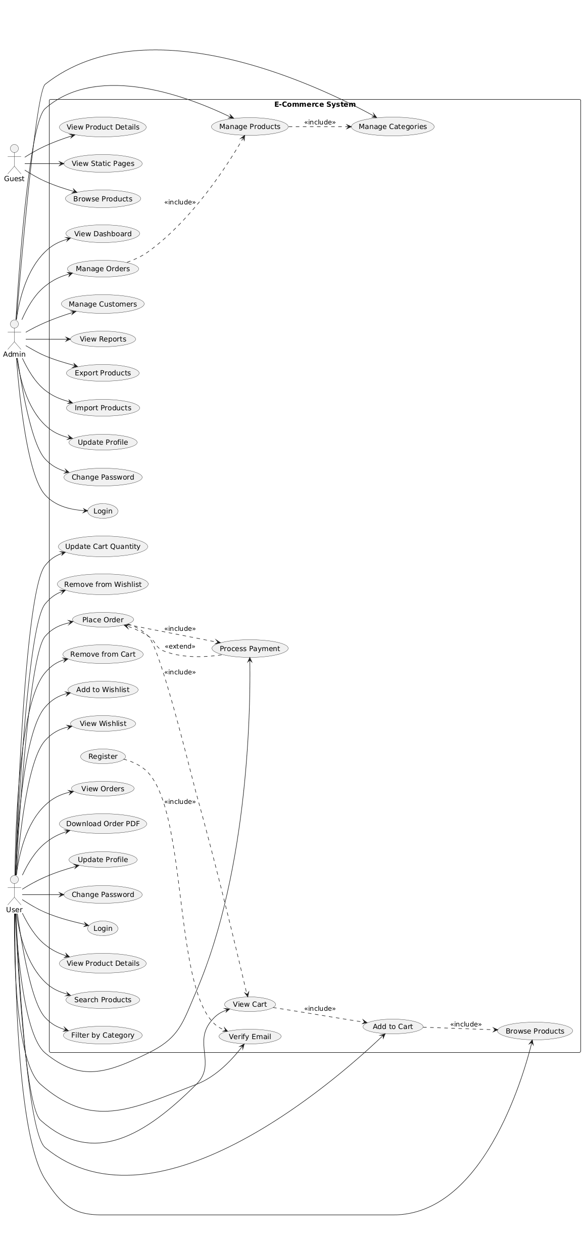
3.2 Class Diagram

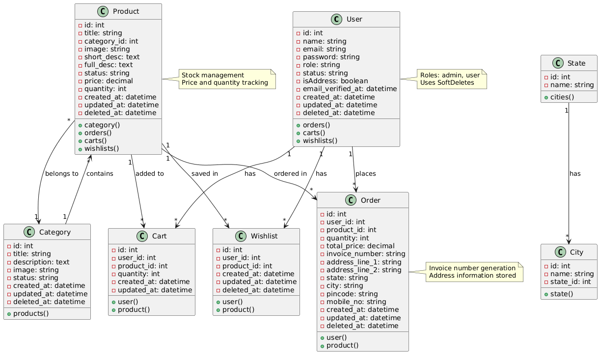

3.3 Interaction Diagram
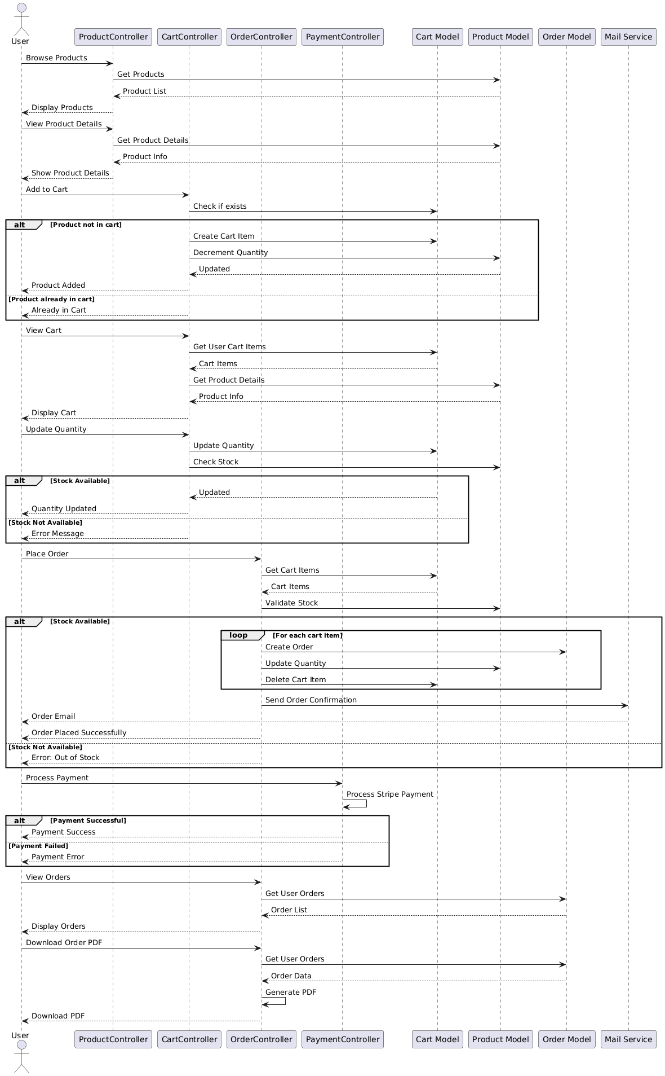

3.4 Activity Diagram
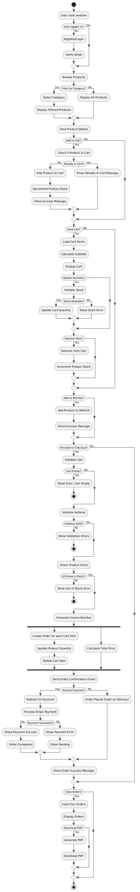

3.5 Data Dictionary
Table name: User Master
Field name | Datatype | Constraints | Description | Sample data
UserId | Varchar2(20) | PK | Enter UserID | YASH
UserName | Varchar2(20) | Not null | Enter UserName | Yash Khalas
Mobile no | int(10) | Not null | Contact Number | 8347727949
Password | Varchar2(12) | Not null | Enter Password | YASH.Sufalam

Table name: Product Master
Field name | Datatype | Constraints | Description | Sample data
ProductId | Varchar2(20) | PK | Enter ProductID | PROD001
ProductName | Varchar2(100) | Not null | Enter Product Name | Samsung Galaxy S21
CategoryId | Varchar2(20) | FK, Not null | Category Reference | CAT001
Price | Decimal(10,2) | Not null | Product Price | 49999.00
Quantity | int | Not null | Available Stock | 50
ShortDescription | Varchar2(200) | Not null | Brief Description | Latest smartphone with advanced features
FullDescription | Varchar2(1000) | Null | Detailed Description | High-performance smartphone with 128GB storage
Image | Varchar2(255) | Null | Product Image Path | images/products/samsung-s21.jpg
Status | Varchar2(10) | Not null | Active/Inactive | Active

Table : Category Master
Field name | Datatype | Constraints | Description | Sample data
CategoryId | Varchar2(20) | PK | Enter CategoryID | CAT001
CategoryName | Varchar2(50) | Not null | Enter Category Name | Electronics
Description | Varchar2(200) | Null | Category Description | Electronic devices and gadgets
Image | Varchar2(255) | Null | Category Image Path | images/categories/electronics.jpg
Status | Varchar2(10) | Not null | Active/Inactive | Active

Table : Order Master

Field name | Datatype | Constraints | Description | Sample data
OrderId | Varchar2(20) | PK | Enter OrderID | ORD001
UserId | Varchar2(20) | FK, Not null | User Reference | YASH
InvoiceNumber | Varchar2(30) | Not null, Unique | Invoice Number | INV-2024-001
OrderDate | Date | Not null | Order Placement Date | 2024-01-15
TotalAmount | Decimal(10,2) | Not null | Total Order Amount | 99998.00
Status | Varchar2(20) | Not null | Order Status | Pending
AddressLine1 | Varchar2(100) | Not null | Delivery Address Line 1 | 123 Main Street
AddressLine2 | Varchar2(100) | Null | Delivery Address Line 2 | Apartment 4B
State | Varchar2(50) | Not null | State | Maharashtra
City | Varchar2(50) | Not null | City | Mumbai
Pincode | Varchar2(10) | Not null | Postal Code | 400001
MobileNo | int(10) | Not null | Contact Number | 8347727949

Table : Order Details

Field name | Datatype | Constraints | Description | Sample data
OrderDetailId | Varchar2(20) | PK | Enter OrderDetailID | ORDDET001
OrderId | Varchar2(20) | FK, Not null | Order Reference | ORD001
ProductId | Varchar2(20) | FK, Not null | Product Reference | PROD001
Quantity | int | Not null | Product Quantity | 2
UnitPrice | Decimal(10,2) | Not null | Price per Unit | 49999.00
SubTotal | Decimal(10,2) | Not null | Quantity × UnitPrice | 99998.00

3.6 User Interface
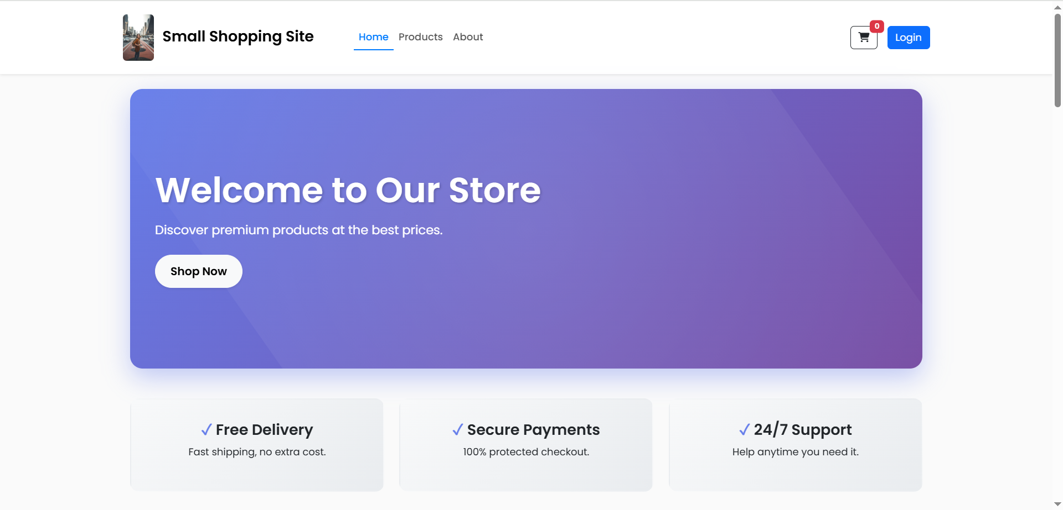
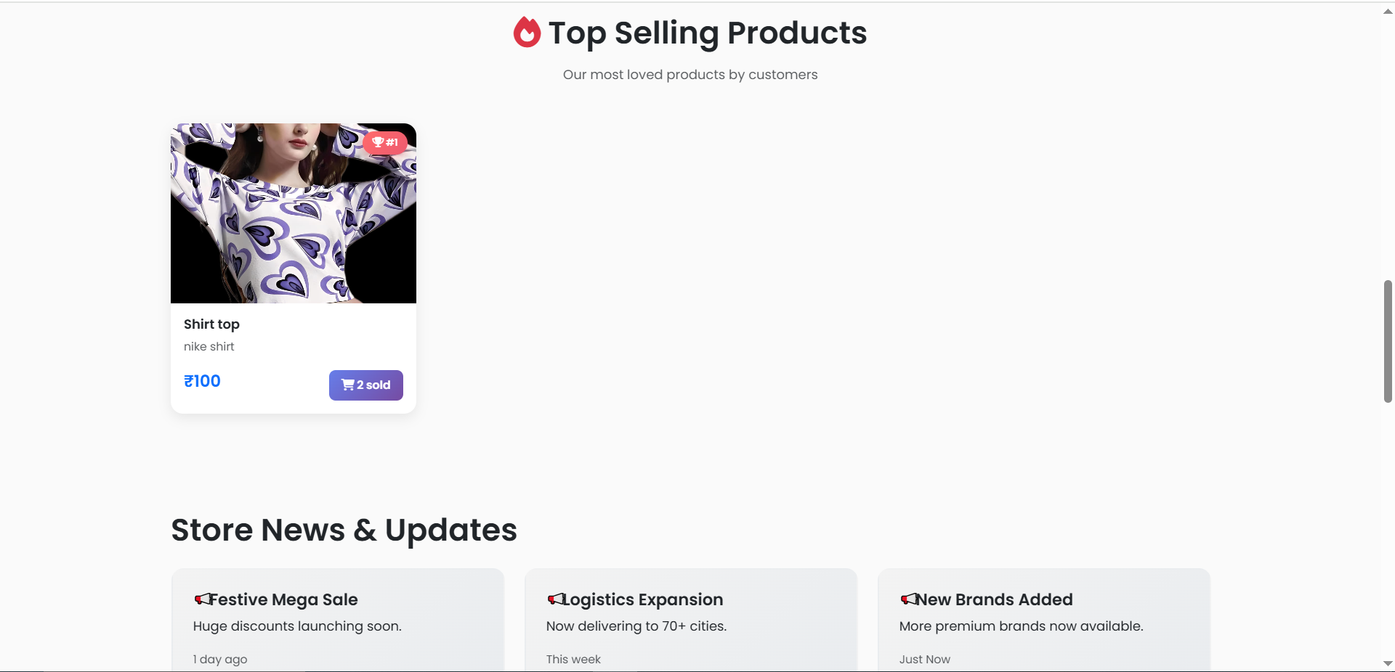
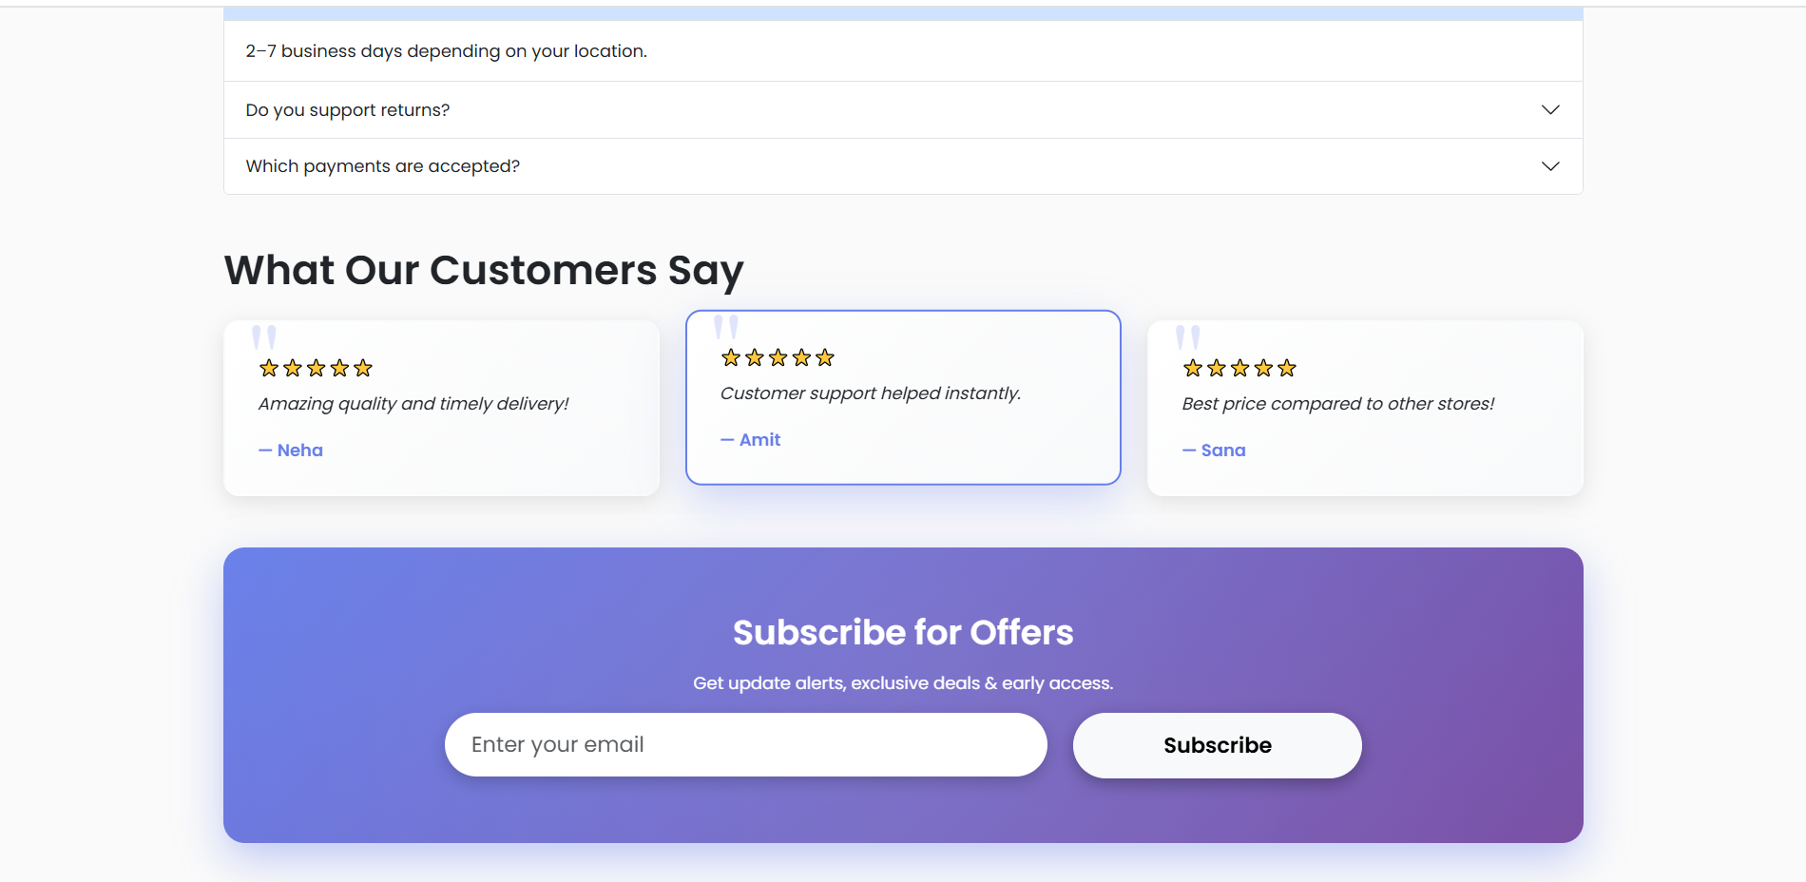
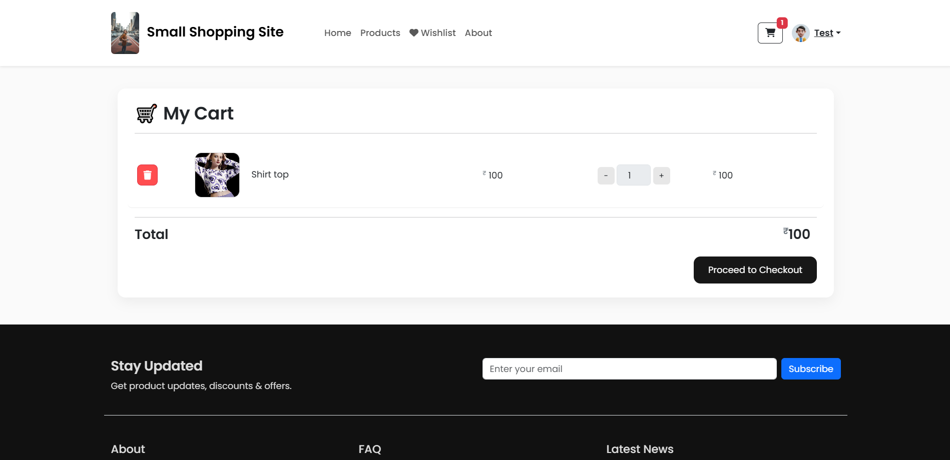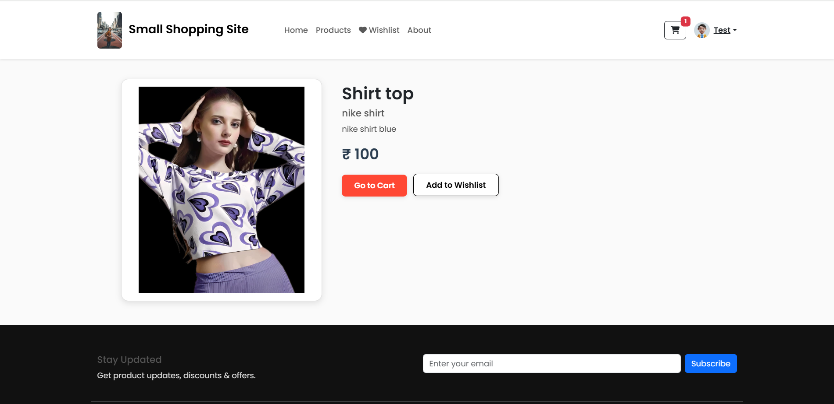
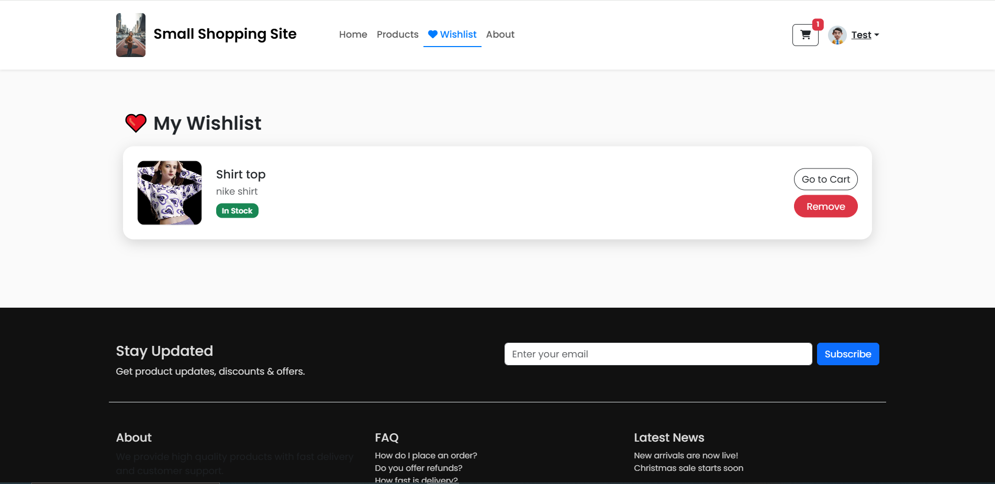
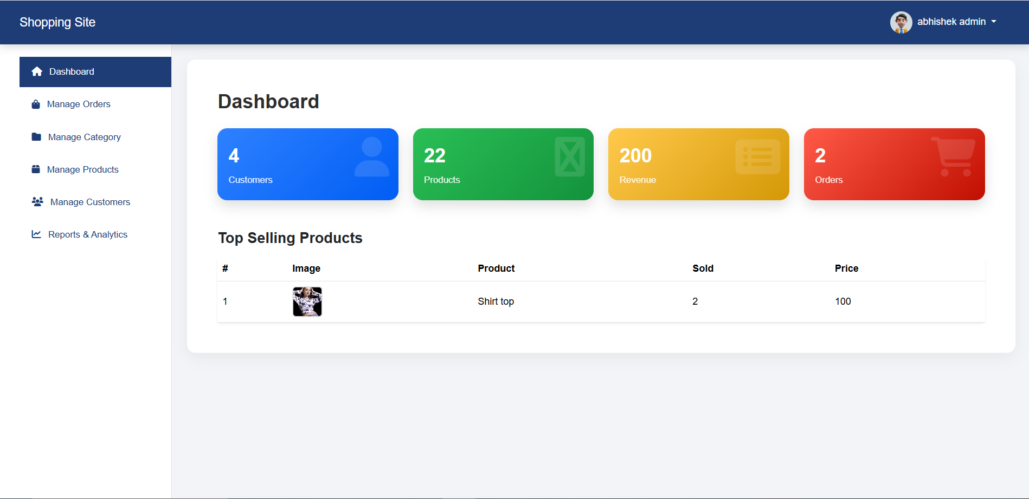
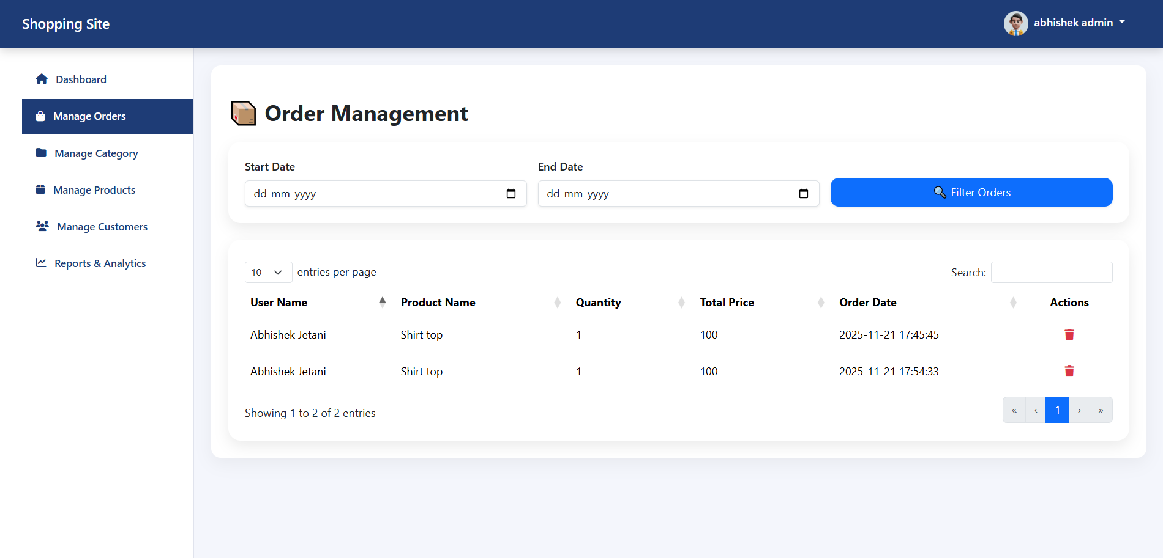
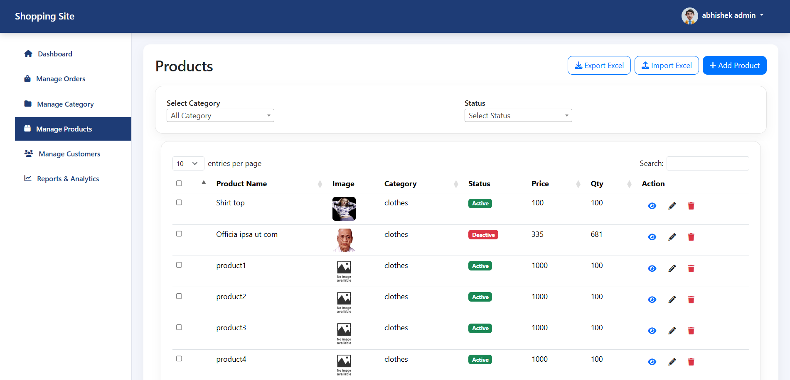
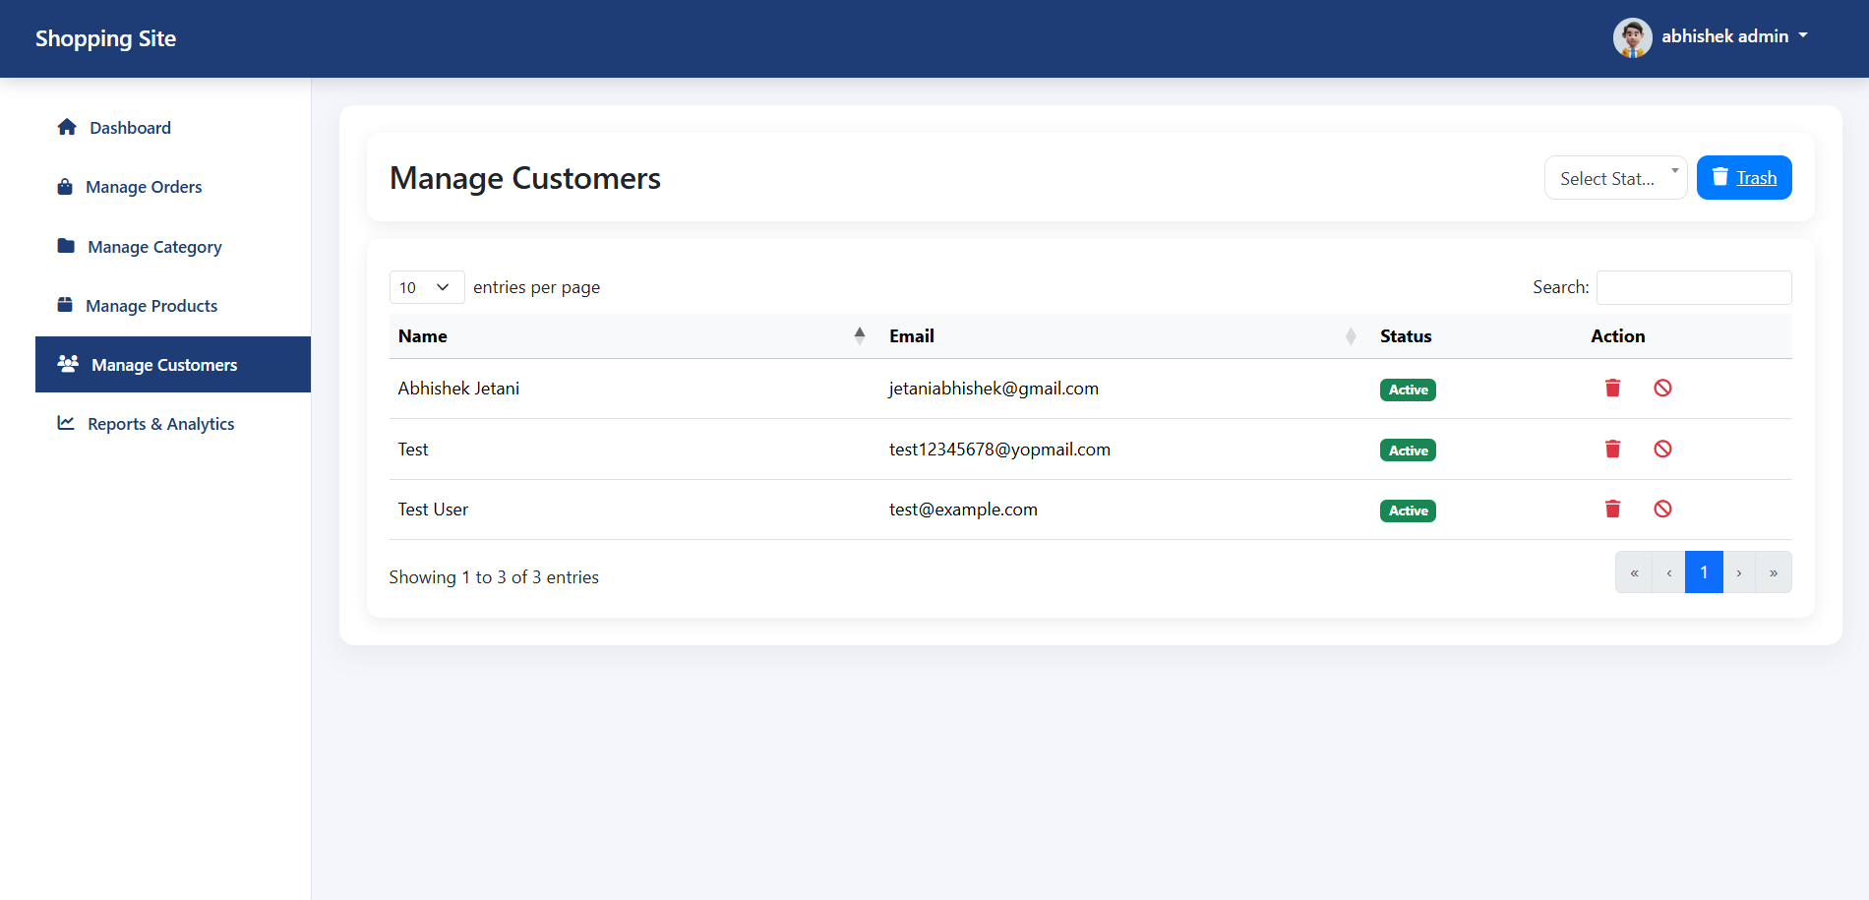
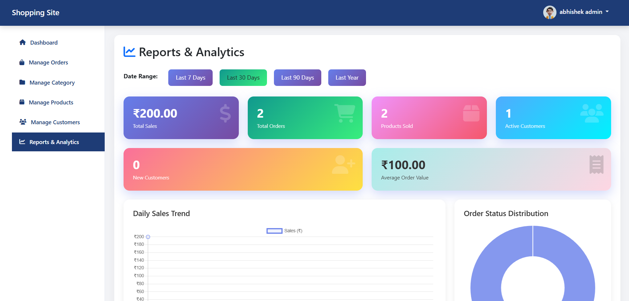
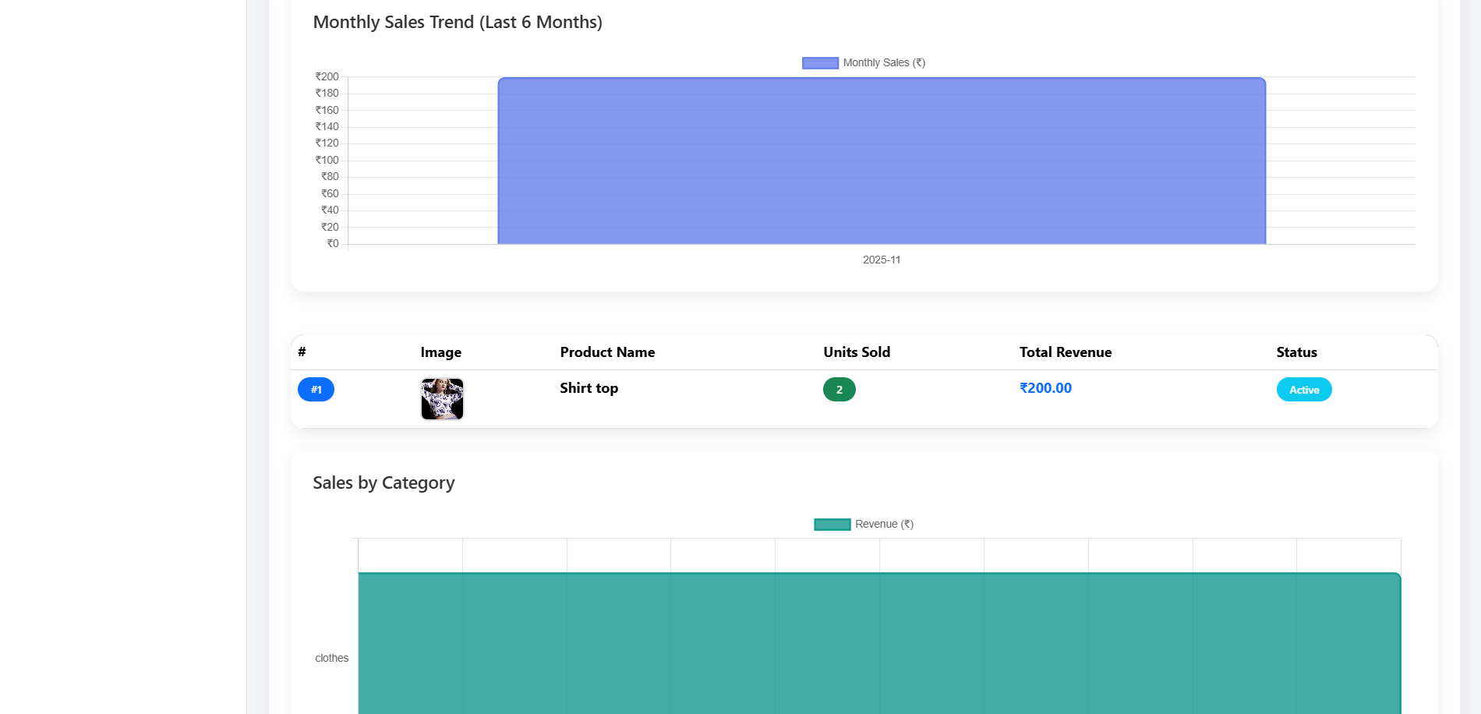

4. Development

4.1 Coding Standards
- Naming convention
- Use meaningful names.
- Function and variable names in snake case.
- Class name in Pascal case.
- Constant snake_case capitalize.

- Indentation/Space
- Use four spaces for indentation.
- Separate top level function and classes with two blank lines.
- Separate method definition inside class by one line.
- Maximum length of line should be less than 80 characters.
- There should be no trailing white spaces.

- Response Status
- Response message with status codes.

5. Agile Documentation
General Project Information
Project Name | Small shopping site
Project Champion | Abhishek Jetani
Expected Start Date | 01-09-2025
Expected Completion Date | 30-11-2025

5.1 Agile Project Charter
The Agile Project Charter serves as a high-level document that defines the scope, objectives, and key stakeholders of the project. It sets the foundation for the project, outlining what the team aims to accomplish, who is involved, and the resources available. Key components of the Agile Project Charter include:
- Project Name: Small Shopping Site
- Project Objectives: To develop a user-friendly e-commerce platform that simplifies product browsing, purchasing, and admin management.
- Project Scope: The project will include a product management module, shopping cart, checkout process, and an admin dashboard for data analytics.
- Key Stakeholders: Project Manager, Developers, QA Testers, Admins, and End Users.
- Budget and Timeline: Define the budget constraints and expected duration of the project, which is from September 1, 2025, to November 30, 2025.

5.2 Agile Road Map
The Agile Road Map provides a visual timeline of the project's development phases, emphasizing the planned sprints and major milestones. It highlights the progression of the project, focusing on key deliverables and sprint goals. The road map ensures all team members understand the project timeline and its iterative nature. Key milestones may include:
- Sprint 1: User registration, authentication, and basic product management setup
- Sprint 2: Shopping cart and wishlist implementation.
- Sprint 3: Order processing, secure checkout, and payment integration.
- Sprint 4: Admin dashboard, analytics, and user/product status management.
- Sprint 5: Final testing, deployment, and user feedback integration.
Sprint | Task Name | Start Date | End Date
1 | User registration, authentication, and basic product management setup | 01-09-2025 | 05-09-2025
2 | Shopping cart and wishlist implementation. | 06-09-2025 | 10-09-2025
3 | Order processing, secure checkout, and payment integration. | 11-09-2025 | 15-09-2025
4 | Admin dashboard, analytics, and user/product status management. | 16-09-2025 | 20-09-2025
5 | Final testing, deployment, and user feedback integration | 21-09-2025 | 25-09-2025

5.3 Agile Project Plan
The Agile Project Plan outlines the detailed schedule, resources, and team assignments for each phase of the project. It emphasizes iterative development through defined sprints, with each sprint focusing on delivering a functional component of the system. The plan typically includes:
- Sprint Schedule: A list of planned sprints, each lasting two weeks, with specific goals.
- Resource Allocation: Assignment of team members to tasks, including developers, testers, and designers.
- Task Prioritization: Backlog grooming to ensure high-priority tasks are addressed first.
- Time Estimation: Estimating the effort required for each user story or task to better manage sprint workloads.

Task Name | Duration | Status
Sprint Schedule | 1 Week | Completed
Resource Allocation | 1 Week | In progress
Task Prioritization | 2 Weeks | pending
Time Estimation | 1 Week | Completed

5.4 Agile User Stories (Minimum 3 Tasks)
Agile User Stories are short, simple descriptions of a feature from the perspective of the end-user. Each user story focuses on the value delivered to the user. The following user stories are examples related to the "Small Shopping Site":
- As a registered user, I want to add products to a shopping cart so that I can review and purchase them later.
  - Task 1: Create a shopping cart interface with "Add to Cart" functionality.
  - Task 2: Implement cart persistence for registered users.
  - Task 3: Enable users to update quantities and remove items from the cart.
- As an admin, I want to manage product details so that I can keep the inventory up to date.
  - Task 1: Develop a form for adding and updating product information.
  - Task 2: Implement product categorization and filtering.
  - Task 3: Add functionality for activating and deactivating products.
- As a user, I want to securely check out my selected items so that I can complete my purchase.
  - Task 1: Integrate payment gateway for secure transactions.
  - Task 2: Develop order confirmation and receipt generation.
  - Task 3: Implement order history tracking for user accounts.

5.5 Agile Release Plan
The Agile Release Plan sets the schedule for the incremental release of features throughout the development cycle. It involves planning which features will be delivered in each sprint and aligning them with the project timeline. This plan ensures a continuous delivery of usable software to the client. Key releases include:
- Release 1: Basic product catalog and user registration.
- Release 2: Functional shopping cart and wishlist.
- Release 3: Secure order processing and checkout.
- Release 4: Admin dashboard with analytics and reporting.
- Final Release: Fully tested system with integrated user feedback.

5.6 Agile Sprint Backlog
The Sprint Backlog is a detailed breakdown of the work planned for the current sprint. It contains a list of tasks derived from the user stories that the development team commits to completing within the sprint period. Each task includes:
- User Stories: Specific features selected from the product backlog.
- Tasks: Decomposed work items necessary to complete a user story.
- Estimates: Time or effort required for each task.
- Progress Tracking: Status updates for each task, such as "To Do," "In Progress," or "Done."
Task Name | Duration | Status
Sprint Schedule | 1 Week | Completed
Resource Allocation | 1 Week | Completed
Task Prioritization | 2 Weeks | Completed
Time Estimation | 1 Week | Completed

5.7 Agile Test Plan
The Agile Test Plan outlines the testing strategy for the project, focusing on continuous integration and validation of features during each sprint. It ensures that bugs are caught early and the quality of the software is maintained. The test plan includes:
- Test Scenarios: Based on user stories to validate each feature's functionality.
- Types of Testing: Unit tests, integration tests, acceptance tests, and regression tests.
- Test Schedule: Coordinated with sprint cycles to allow for iterative testing.
- Bug Reporting and Tracking: A system for documenting and resolving issues found during testing.

5.8 Earned-Value and Burn Charts
Earned-Value and Burn Charts provide visual representations of the project's progress and team efficiency. These charts help the team assess whether they are on track with their planned timeline and budget.
- Burn-Down Chart: Illustrates the amount of work remaining in a sprint. It helps in visualizing progress toward completing the sprint's goals.
- Burn-Up Chart: Shows work completed over time, helping to identify scope changes.
- Earned Value: Measures the project's performance and progress by comparing planned work with the completed tasks. It helps in forecasting project completion and identifying any delays.
6. Proposed Enhancement
Proposed enhancements for the aim to create a user-friendly e- commerce experience with efficient product management. Key enhancements include:
- Implementing a user-friendly interface for browsing products, adding items to the cart, and managing orders.
- Introducing real-time inventory tracking to ensure product availability is accurately reflected to users.
- Integrating analytics tools to monitor user behaviour, track sales trends, and optimize inventory management.
- Enhancing search and filtering capabilities to help users easily find products based on categories, price, or ratings.
- Enabling role-based access control to allow admins to manage inventory, monitor orders, and analyse reports securely.
- Optimizing site performance to handle high user traffic and concurrent orders efficiently.
- Providing detailed reporting functionalities for admins to analyse sales data, identify popular products, and make data-driven decisions.

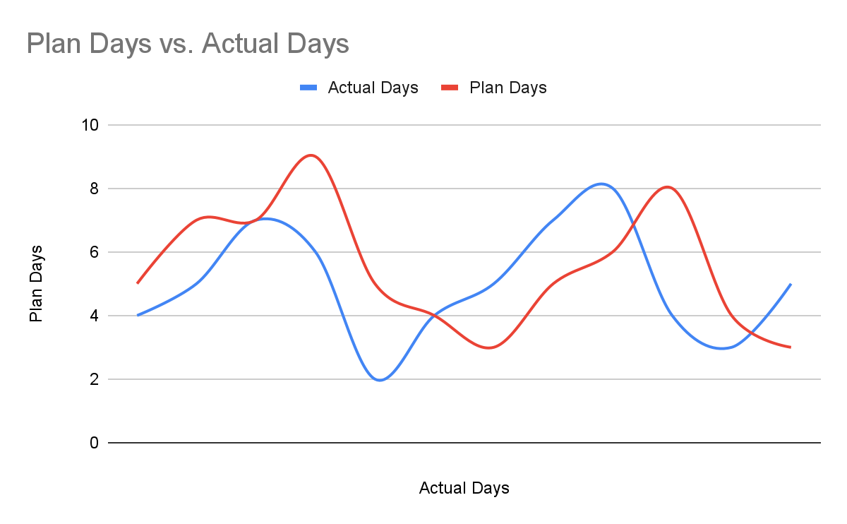
7. Conclusion
The proposed Small Shopping Site offers a robust solution for online shopping needs by streamlining the browsing, purchasing, and management processes. With features like real-time inventory tracking, enhanced search capabilities, and secure payment integration, the platform ensures a seamless shopping experience for users.
Additionally, advanced tools such as analytics and automated notifications empower administrators to optimize operations and improve customer satisfaction. With a foundation for continuous improvement and adaptability to future requirements, the Small Shopping Site is poised to deliver significant value to both end users and business administrators.

8. Bibliography
• Laravel Documentation
Laravel Framework — Official Documentation.
Available at: https://laravel.com/docs (Accessed 2025).
• Welling, L., & Thomson, L.
PHP and MySQL Web Development. 5th Edition. Addison-Wesley, 2016.
• E-Commerce Concepts and Technologies
Laudon, K. & Traver, C.
E-Commerce: Business, Technology, Society. 15th Edition. Pearson, 2021.
• MySQL Documentation
Oracle — MySQL Reference Manual.
Available at: https://dev.mysql.com/doc/ (Accessed 2025).
• Bootstrap Documentation
Bootstrap — Official Website.
Available at: https://getbootstrap.com/ (Accessed 2025).

